

M.S. Software Project Management

Project 1 Report

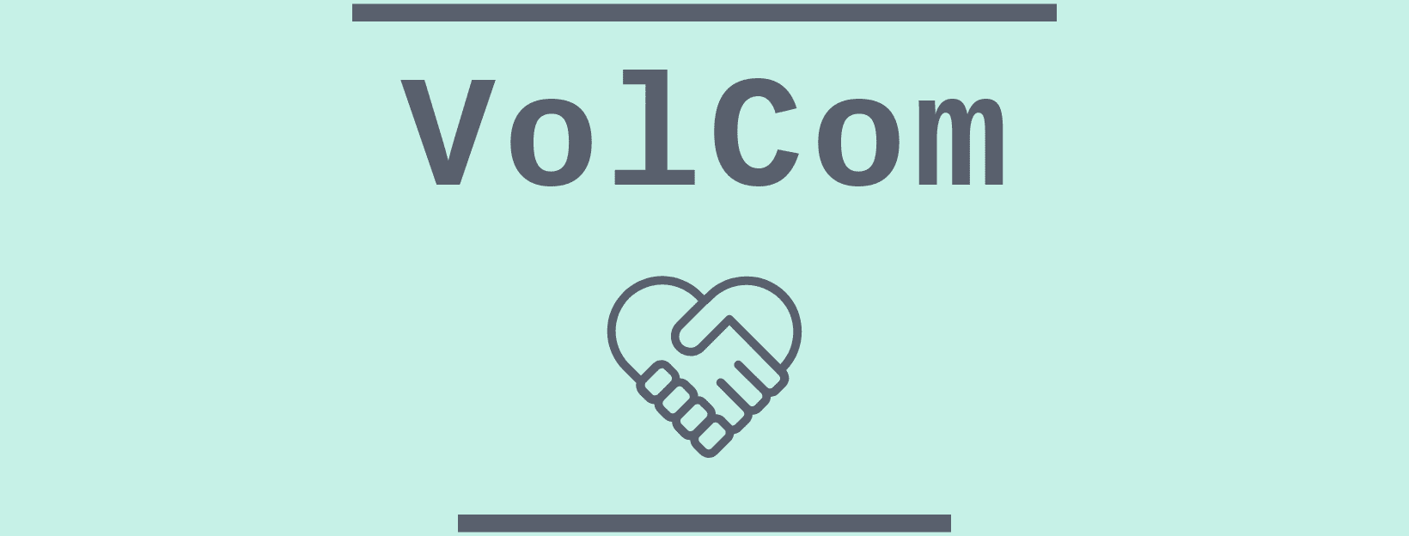

Building Community of Volunteers

Project Supervisor

Engr. Abdul Rahman Mahmood

FAST- NATIONAL UNIVERSITY OF COMPUTER AND EMERGING SCIENCES, KARACHI

Android based Volunteering App

Sajjad Alam | K16-3412

2019

Declaration of Originality

VolCom:

I certify that this work is free of plagiarism and all materials appearing in this report have been properly quoted and attributed.

Further, I certify that I am the sole author of this report and this report and that no part of this report has been published or submitted for publication.

I declare that this a true copy of my report, including any final revisions, as approved by my supervisor and the project committee, and that this report has not been submitted for a higher degree to any other University or Institution.

_________________________

Sajjad Alam

_______________________________

Date (day/month/year)

Supervisor Approval

The Undersigned certify that they have read, and accept the document entitled “MS-Project I Report” Submitted by Sajjad Alam, student of MS-SPM.

In Partial Fulfillment of the Requirements for the Degree of Master of Education

__________________________

Mr. Engr. Abdul Rahman Mahmood

_______________________________

Date (day/month/year)

Document History

|  |  |  |  |
| --- | --- | --- | --- |
| **Version** | **Name of Person** | **Date** | **Description of change** |
| 0.1 | Sajjad Alam | 1/12/2019 | Initial Document Created |
| 0.2 | Sajjad Alam | 10/12/2019 | Draft 1 |
| 0.3 | Sajjad Alam | 22/12/2019 | Draft 2 |
| 0.4 | Sajjad Alam | 26/12/2019 | Document Ready |
| 1.0 | Sajjad Alam | 28/12/2019 | Sign off |
|  |  |  |  |
|  |  |  |  |

Distribution List

|  |  |
| --- | --- |
| **Name** | **Role** |
| Mr. Abdul Rahman Mahmood | Supervisor |
|  |  |
|  |  |

Document Sign-Off

|  |  |  |
| --- | --- | --- |
| **Version** | **Sign-off Authority** | **Sign-off Date** |
| 1.0 | Mr. Abdul Rahman Mahmood |  |
| 1.0 | Project Committee |  |
|  |  |  |
|  |  |  |
|  |  |  |
|  |  |  |
|  |  |  |

Table of Contents

INTRODUCTION AND BACKGROUND 8

PURPOSE OF DOCUMENT 8

INTENDED AUDIENCE 8

DOCUMENT CONVENTION 8

INTRODUCTION 8

PROBLEM STATEMENT 9

PREVIOUS WORK 9

BACKGROUND 10

MOTIVATION 10

ACKNOWLEDGMENTS 10

PROJECT METHODOLOGY 10

OPERATING ENVIRONMENT 11

PROJECT DESCRIPTION 12

FUNCTIONAL SPECIFICATION 12

FUNCTIONS PERFORMED 12

OTHER APP FEATURES 14

LIMITATIONS AND RESTRICTIONS 14

INITIAL USER INTERFACE DESIGN 15

EQUIPMENT CONFIGURATION 15

SOFTWARE 15

HARDWARE 16

SOFTWARE CONSTRAINTS: 16

HARDWARE CONSTRAINTS: 16

CULTURAL CONSTRAINTS: 16

LEGAL CONSTRAINTS 16

USER CONSTRAINTS 16

REQUIREMENT SPECIFICATION 16

DISTINCT USERS 16

DELIVERABLE ITEMS 17

NON-FUNCTIONAL REQUIREMENTS 17

USER STORIES 18

DESIGN AND SPECIFICATION 19

SYSTEM DIAGRAM & DESCRIPTION 19

SYSTEM STRUCTURE CHART 21

ACTIVITY DIAGRAM 22

SEQUENCE DIAGRAM 23

DEPLOYMENT DIAGRAM 24

ARCHITECTURE DIAGRAM 25

TABLE DIAGRAM 27

CLASS DIAGRAM 28

USE CASES 29

TEST PLAN STRATEGY 32

PROJECT FEASIBILITY 33

OPERATION FEASIBILITY 33

SOCIAL FEASIBILITY 33

RISKS 33

PROTOTYPE DESCRIPTION AND DEMO 34

MILESTONE DETAILS 36

SCHEDULE OF MILESTONE DESCRIPTION 36

APPENDICES 37

REFERENCES: 37

# INTRODUCTION AND BACKGROUND

## PURPOSE OF DOCUMENT

The purpose of this document is to provide complete detail on the overall picture of the proposed project, its features and goals. This report also gives an account of the project proposal to ascertain the prospects of the proposed plan/activity. This project describes all objectives, stakeholders and their interaction including use cases, design structure, functional specification as well as hardware & software requirements and other artifacts necessary to understand and complete the project. This report will include the details of the project's requirements, components, enslavements, product features and the overall explanation of the project.

## INTENDED AUDIENCE

The following audience would be part of this document:

Developer

Project Supervisor

Project Committee

## DOCUMENT CONVENTION

Main Headings and subheadings both have the 14 font size

Times New Roman font type is used in all the headings, subheadings and body

## INTRODUCTION

In social media age, every details regarding to our problem as a society is highlighted very quickly and everyone raise voices for the resolution. Our society is full of problems that are created by us and the need to be addressed more than ever now. Problem like littering, green environmental issues and awareness issues etc. As a Karachites, we have huge number of population and if energy that lies inside it, channelized properly, can create huge difference. We have seen young generation waste most of their time sitting, chatting drinking teas etc.

With time, issues are piling up and organization like fixit comes forth whose ideology is to self-help rings my thought to build an app which can connect such people who want to give back to society

## PROBLEM STATEMENT

“To build an android application to provide a social platform using mobile devices from which issues related to vicinity, awareness drive, protest can be raised and build a team to solve those issues voluntarily in a most simplistic way, in other words build community of volunteers and give power to individuals who are always willing to execute for betterment of society.”

## PREVIOUS WORK

There are very few organizations that are running their volunteering services but not everybody is connected to them and they are supervised by their own policies and limitations. There are few local groups also that try to solve issues by their own as well single person initiatives also popup on media now and then. How technology can help these groups and individuals is what this project is trying to address. Most of the open source work related to this project is web based and not according to our local problems. Some paid apps are also available but they are to be brought by organization who offer their services such as “Make a wish” and “The Citizen’s Foundation”. Some apps are only doing volunteer managements for individuals similar to task management. Application related to problem statements are

GiveGap: Its IOS based app which is a fundraising platform built for nonprofit organizations. Major features are Volunteering Management, Campaign Management, and Donations Collection

Give Today: Its android, US only based application which is donation centric volunteering features

Kiwanis: Its fairly complex app with huge set of features and US based

There are few more similar platforms like Volunteer App and My Selfless Act. These apps either used by organizations to manage their volunteering services or individuals to manage their volunteer works. Facebook events can also be used to solve such need but it lacks volunteering functions. Gaps that I found in available apps is that they are location specific or web based, and organization controlled, used commercially and complex for our needs. Some apps do fairly simple thing like collecting issue details and sending it to authorities to take actions.

## BACKGROUND

Individuals deserve the opportunity to gain fulfillment through volunteering without having to jump through hoops. Technology should be used to facilitate deeper, fulfilling connections with those around us and that true happiness comes from the satisfaction of work related to improve living standard around common people, by making it easier to volunteer (and to manage volunteers).It make a good use of technology to link up idle humanly time and resources and preform activities that can be beneficiary to society.

## MOTIVATION

The motivation for this projects derived from the idea of community-based technology development initiatives. Living in a country where government have limited resources and problems are bigger than usual and continuously getting problematic sparks idea of taking action without dependencies. According to research, 65% population in Pakistan is under 35 years of age. Over 60 million user have access to digital world. Idea of this app is to provide an enabling environment volunteering, without any dependency of local service providers (Volunteering Service) as well as building community of volunteer using social interaction provided. Hence its contribution to the society can be in the form of awareness, better utilization of time, self-service and problem resolution.

## ACKNOWLEDGMENTS

Making this report has been a pleasant experience. The knowledge and experience gained is immeasurable. One of the most pleasant parts of writing this report is the opportunity to thank those who have contributed to it. These acknowledgments are no exception. My thanks and utmost regards goes to our advisor “Mr. Abdul Rahman Mahmood " who gives brief description in every document provides help when we faced some problems in Project. And a friend "Shahid Aslam", who provided us the thoughtful suggestions to make the project initiate.

## PROJECT METHODOLOGY

I will use different development tools to accomplish our objective. I will frequently check the effects of changes in our framework to the behavior of agents in our application every step of the way, and then haul out the code for a general framework. As started it was clear that Waterfall method is used with some type of prototyping methodology is used as software development model

## OPERATING ENVIRONMENT

User Workstations

An Intel Core i5 (1.7 GHZ)

4GB of RAM (1GB recommended)

1 GB of free disk pace

Same machine is used as Server/Database Machine

# PROJECT DESCRIPTION

The vision behind this project is to let our people fix issues created by us, lack of governance etc. and to promote self-volunteerism in one own capacity without relying on other forces. The aim of the project named “VolCom” is to develop an android based application that shall enable group of people or individual to raise local issues, share them on social media, connect with each other, fix them collectively or escalate them to concern authorities. This project promote an idea of teams and to build community of volunteers. Since self-initiative is the core driving factor of this application, Gamification and social media sharing will help build continuous interest. People who cannot participate, can donate for the raised event.

## FUNCTIONAL SPECIFICATION

This section specifies the functions that a system or component must perform. The documentation typically describes what is needed by the system user as well as requested properties of inputs and outputs.

### FUNCTIONS PERFORMED

#### Profile module

This module represents the profile of the user and has following high level functions

* + Create/Update their profile
  + Manage and monitor selected events
  + Reviews and feedback
  + Track services you are engaged in

#### Team module

Team module is a set of user profiles joins as a team to perform particular tasks

* + Manage teams
    - Create/Update
    - Delete
    - Join or unjoin

#### Local Issue module

This module contains issue details that need to be raised by the user

* + Create/Update
  + Attach media related to it
  + Escalate to concern authorities
  + Status management
  + Monitor likes and Comment
  + Moderate
  + Share on Social Media
  + Send it to mobile Contact list

#### Events module

This module is built to cater event functionality. Events are objects that is created against any reported issue and it can only be created as a member of a team

* + Create and manage
  + Participation
  + Share it on Social media
  + Send it to mobile Contact list
  + Attach media related to it
  + Track and monitor
  + Donate for an event
  + Ratings and feedback
  + Moderate
  + Set closure for that event

#### Time line Module

This is the main splash screen module of the app where all the happening inside application can be viewed by the user. It’s the most simplistic version of Facebook news feed. This includes

* + Media Files related to events happening
  + Like and Comments
  + Share to Social platform and Contact list

#### Volunteering Tracking

Participation in events and activities can be managed using In App volunteering management system where user can track hours of volunteering and monitor them. This includes

* + Monitoring
  + Set Goals
  + Update Details

### OTHER APP FEATURES

#### In App Chat Module

Through this module, teams can communicate each other and maintain communication for the record what happened during an event.

#### Team, User and Event Ratings

As stated above, this application will use gamification technique to indulge user to use this application which includes but not limited to rating and building profile

#### Event search

User can view all active events as well as completed events and can search it related to the tags or key words

## LIMITATIONS AND RESTRICTIONS

* + Since this application will perform its major functions over the internet, internet connection is necessary.
  + This Application will be developed for Android only.
  + Only Facebook social media will be considered
  + Payment and donation will be build according to availability but system will be built to be able to connect
  + The scope of this project does not involve complying with any standards, operating framework or protocols.

### INITIAL USER INTERFACE DESIGN

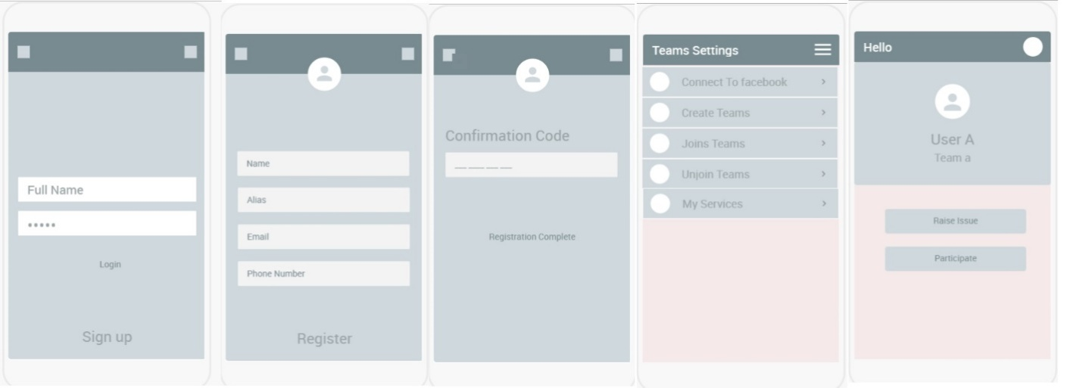

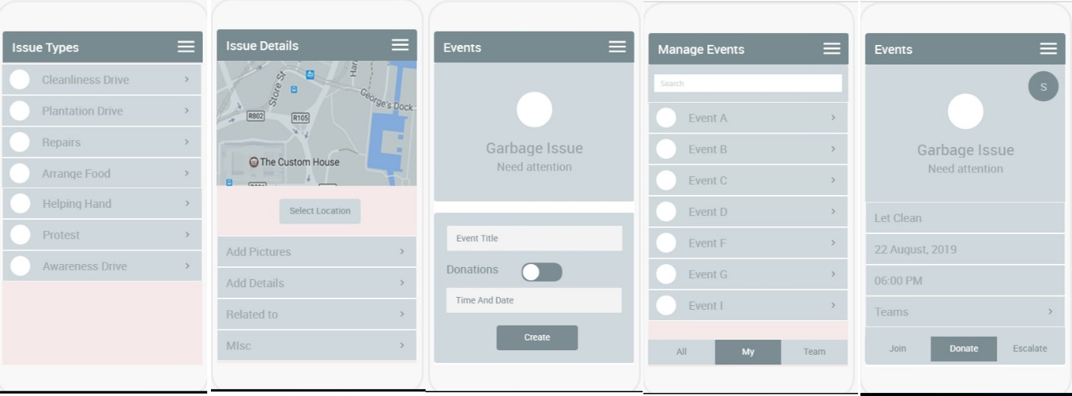

Fig. 1 User Interface Mockups

## EQUIPMENT CONFIGURATION

### SOFTWARE

* Android Studio
* Visual Studio
* SQL Management Studio
* Apache Cordova
* MS SQL Server
* Rest service API
* Google map API
* Facebook sharing API
* Payment Gateway
* Just In Mind For Prototyping
* MS Visio and Creatly for Technical Illustrations

### HARDWARE

* Android Device
* Service application server
* Database server

### SOFTWARE CONSTRAINTS:

* As the solution is being developed on windows platform the system cannot run on any other platform other than windows.
* The system can't run if .NET framework is not installed on the machine that is the system is not platform independent.

### HARDWARE CONSTRAINTS:

* The minimum required hardware configuration is described in “Operating environment Section”.

### CULTURAL CONSTRAINTS:

* None

### LEGAL CONSTRAINTS

* None

### USER CONSTRAINTS

* User must be able to use social platform on mobile and understand English.

## REQUIREMENT SPECIFICATION

This project will be based upon android mobile application. The application will for main functionalities such as creating issue, raising issue against the issue, sharing to social media, monitoring and in app messaging. To build this app, minimum dependencies is focused to remain architecture simple and cost reduced.

### DISTINCT USERS

This App is used by anybody that has access to internet and has android phone. Those who are affected by any problem related to surrounding can raise the issue and does self-service act to resolve that issue by bringing likeminded people along. Either user can initiate the process of resolution or be the part of it my joining team or join as an individual.

### DELIVERABLE ITEMS

* Prototype
* Mockup Screens of Android
* Android executable APK file
* Source code of the application
* Project report and other documentation

### NON-FUNCTIONAL REQUIREMENTS

PERFORMANCE REQUIREMENTS

(a) 90% of the responses should be within 1 sec except initializing the system for which more time is acceptable. However, it may vary depending on the mobile configuration.

(b) System shall be able to handle large number of transactions and should accept all the queries given.

SECURITY REQUIREMENTS

There are no specific security and privacy requirements, other than those generally governing use of user login accounts on the particular system. User has to enter his/her account ID and password to login in the system. Every user has different login ID and password.

### USER STORIES

User stories are short, simple descriptions of a feature told from the perspective of the person who desires the new capability, usually a user or customer of the system.

#### Joiner Stories

* As a user I must be able to register and login so that I should be able to join team.
* As a joiner, I can see event going on and can able to join available events.
* I can communicate with the initiator as well as members who have joined this event.
* I can share it on social media platform or contact list of my phone
* I can track the progress of the event
* I can maintain my hours of volunteering

#### Raiser Stories

* As a user I must be able to register and login so that I should be able to create issue.
* As a raiser, I must be able to raise event around the issue I created.
* I must be able to share this event on the wall of the app as well as share it on other social platform and contacts.
* As a raiser, I must be able to edit that event, maintain them and management teams and individuals joined.
* I must be able to rate teams and individuals joined
* I must be able to monitor progress and closure of the event.

#### Sharer Stories

* As a user I must be able to register and login so that I should be able to view issues and event available.
* I must be able to give feedback, comments or like to the event.
* I must be able to endorse the issue and must be able to share it on other social platform and contacts

#### Donator Stories

* As a user I must be able to register and login so that I should be able to view issues and event available.
* I must be able to give feedback, comments or like to the event.
* As a joiner, I can see event going on and can able to join as a donator and provide donation of the event

# DESIGN AND SPECIFICATION

## SYSTEM DIAGRAM & DESCRIPTION

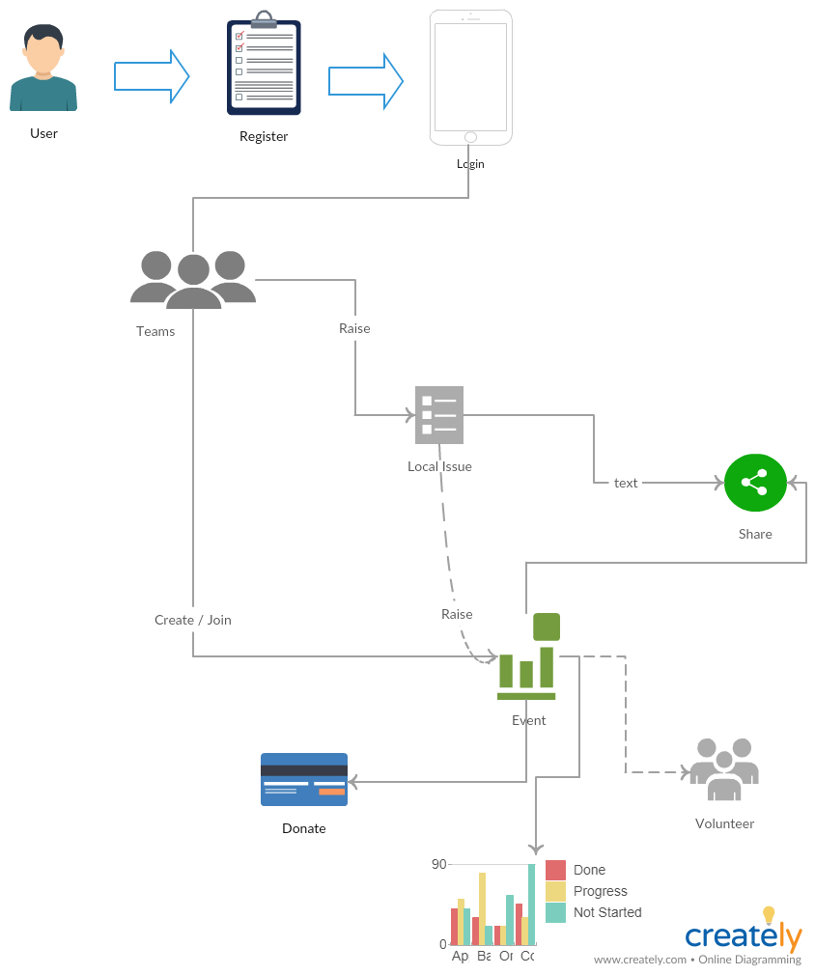

Fig. 2 System Diagram

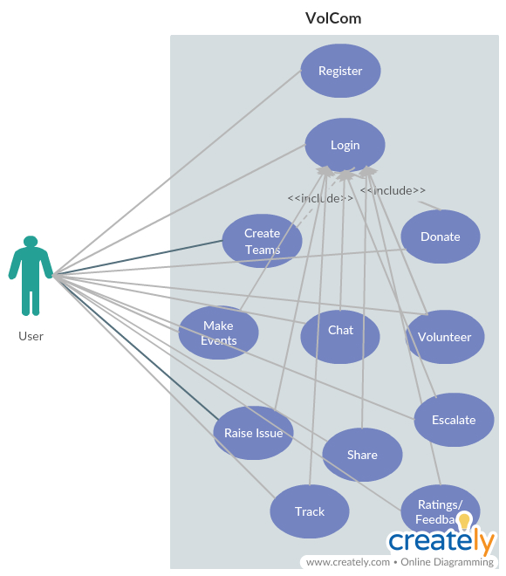

Fig. 3 user case interaction

The above diagram is overall system use case, representing the interaction of user.

## SYSTEM STRUCTURE CHART



Fig. 4 System architecture

## ACTIVITY DIAGRAM

ccc

Fig. 5 Activity Diagram

The activity diagram of the system states each distinct activity that can be performed using the system. From User registration as a new user, to login and then creating team or joining it, or searching or raising issue and creating event around that issue and managing it.

SEQUENCE DIAGRAM Fig. 6 Sequence Diagram

## DEPLOYMENT DIAGRAM

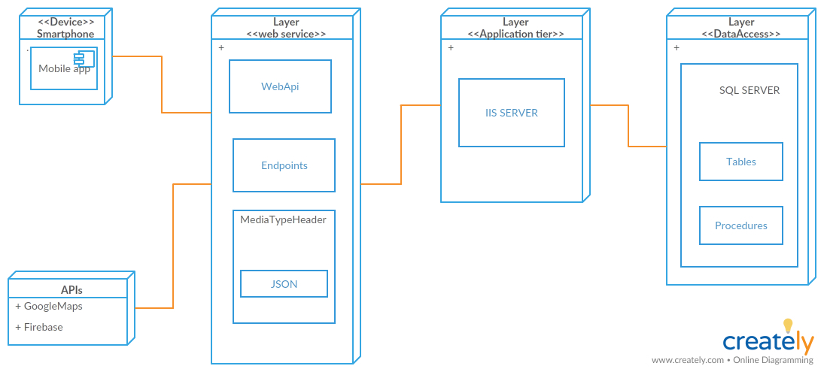

Fig. 8 Deployment Diagram

Deployment diagram is a structure which depicts the concrete elements in the physical world that are the result of a development process. They model physical hardware elements and the communication paths between them.

## ARCHITECTURE DIAGRAM

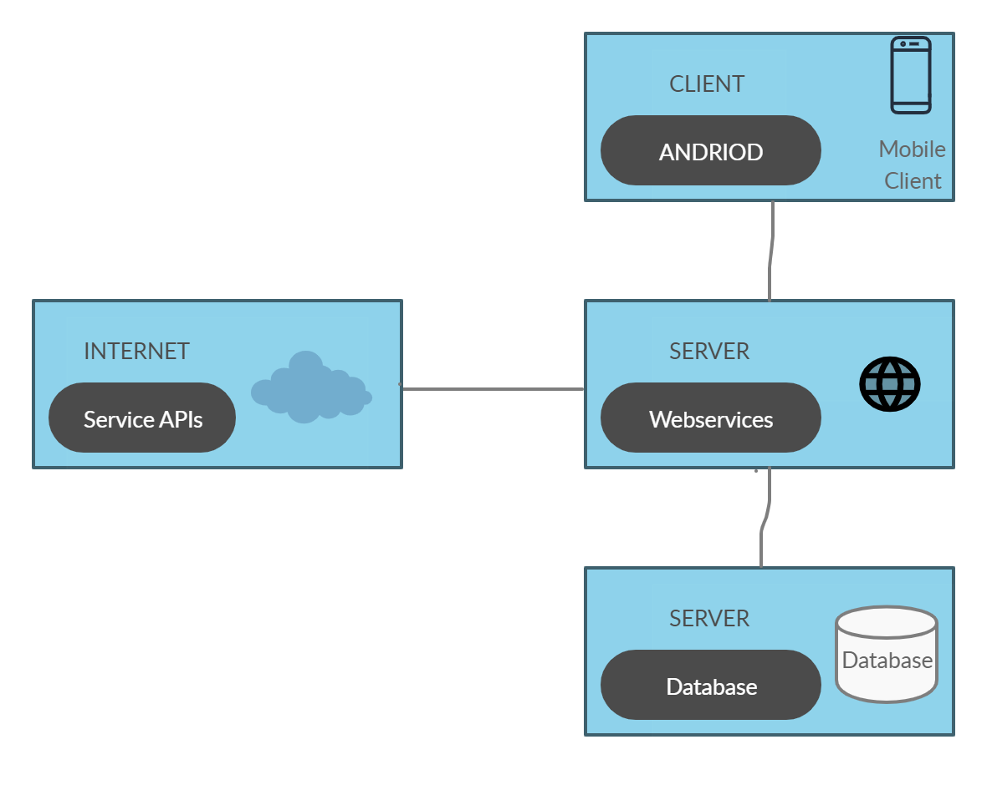

Fig .9 Architecture Diagram

The above figure depicts the tentative class structure of the system.

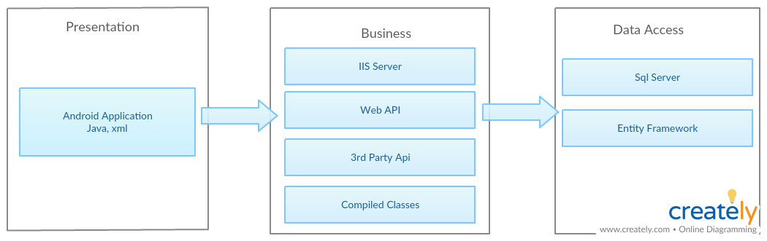

Fig. 10 Application Layers

Application is divided into three layers

PRESENTATION LAYER

This is the android application which will interact with the user

MIDDLE/BUSINESS LAYER

The middle tier layer is the mapping mechanism which will interact with the server

DATA ACCESS LAYER

The Database layer is the data access layer which is at the back end and is accessed by the server.

## TABLE DIAGRAM



Fig.11 Table Diagram

The above figure depicts the tentative database structure of the system. The tables may increase when the project progress.

## CLASS DIAGRAM

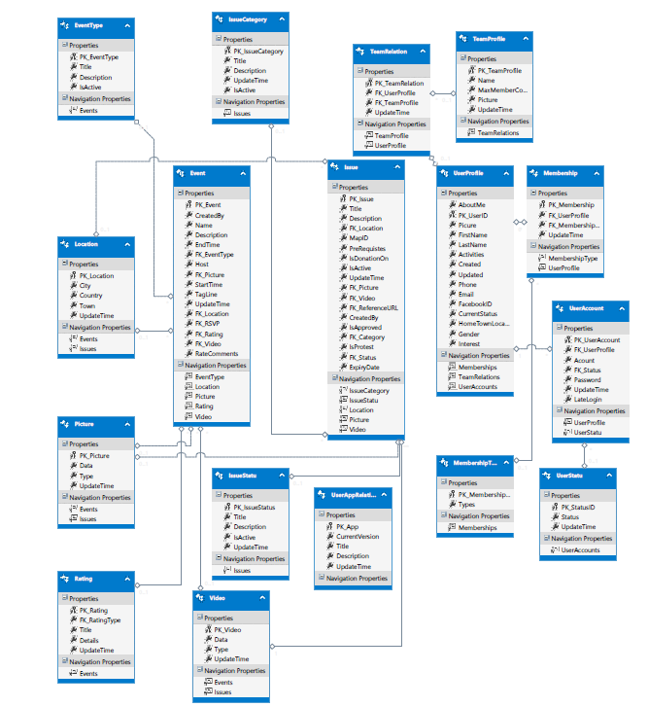

Fig. 12 Class Diagram

The above figure depicts the tentative class structure of the system. The classes may increase when the project progress.

## USE CASES



|  |  |
| --- | --- |
| Actor | Event Creator |
| Description | Create Event of the issue by providing details briefly |
| Precondition | User should be login, should be member of a team and issue has been raised in the team. |
| Post Condition | Event should be made public to be view by audience of the application |
| Normal flow of event | User login in the application.  Create an issue or select an issue created by team member.  Provide details. Create an event.  Publish this event. |



|  |  |
| --- | --- |
| Actor | Event Participator |
| Description | View published events and joins it to participate. |
| Precondition | User should be login, should be member of a team and event has been published to be participated. |
| Post Condition | - |
| Normal flow of event | User login in the application.  View events.  Participate in that event.  Share this event. |



|  |  |
| --- | --- |
| Actor | Event Donator |
| Description | View published events and joins it to participate as a donator and give amount for particular event. |
| Precondition | User should be login, and conditions related to payment system are fulfilled. |
| Post Condition | - |
| Normal flow of event | User login in the application.  View events.  Participate in that event.  Give a donation. |

## TEST PLAN STRATEGY

*.*

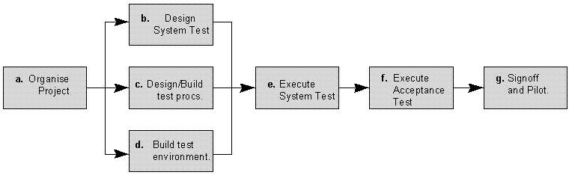

Fig . 15 Test Plan

The diagram above outlines the Test Process approach that will be followed.

* **Organize Project** involves creating a System Test Plan, Schedule & Test Approach, and assigning responsibilities.
* **Design/Build System Test** involves Test Case, Actual Results, Expected Results, etc. In general, test conditions/expected results will be identified first by our Team. The Team will then identify Test Cases and the Data required. The Test conditions are derived from the Software Specifications Requirement Document.
* **Design/Build Test Procedures** includes setting up procedures such as Error Management systems and Status reporting.
* **Build Test Environment** includes requesting/building hardware, software and data set-ups.
* **Execute System Tests –** The tests identified in the Design/Build Test Procedures will be executed. All results will be documented.
* **Signoff** - Signoff happens when all pre-defined exit criteria have been achieved

# PROJECT FEASIBILITY

## OPERATION FEASIBILITY

This Application is being built keeping in mind that our local body of government is not doing adequate work and not putting in enough resources to resolve basic civic problem of citizen, which raises the need to of doing these activities such as garbage collection, plantation drive or raising awareness drive. Few NGOs have stepped in to take action on it and converting the utilization of human resources to self-service activities. To drive this motivation into more robust, tractable and maintainable outcome, this app can take it forward using technology available. Current technology stack give us power to leverage this idea to bring positive change in society where an individual can take part in such activities and grow volunteering capacity within. There is cost involved to maintain such system however, business models has evolved now to sustain itself by introducing different financial tool which includes digital marketing, donations etc. This app is built using well known technologies and simple tooling to be maintained easily. Since currently it’s a university level project, other feasibility matter are deliberately not put into consideration.

## SOCIAL FEASIBILITY

Since it is kind of social app where user can collaborate and communicate, social norms will raise difficulties to accept it. Currently no tool is used to find feasibility that runs along finding social acceptance.

## RISKS

SMS gateway and Payment gateway are paid services therefore might get in to problem by integrating those APIs

# PROTOTYPE DESCRIPTION AND DEMO

REGISTRATION

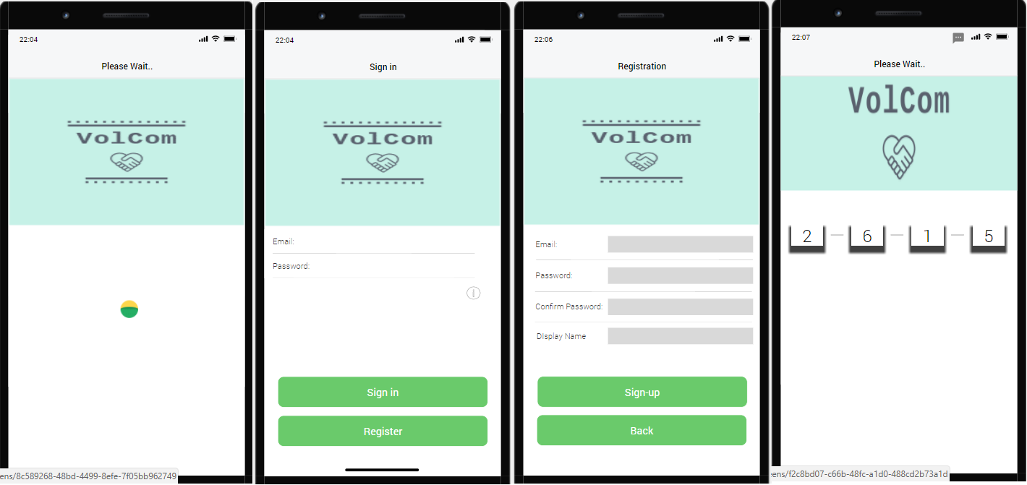

HOME SCREEN

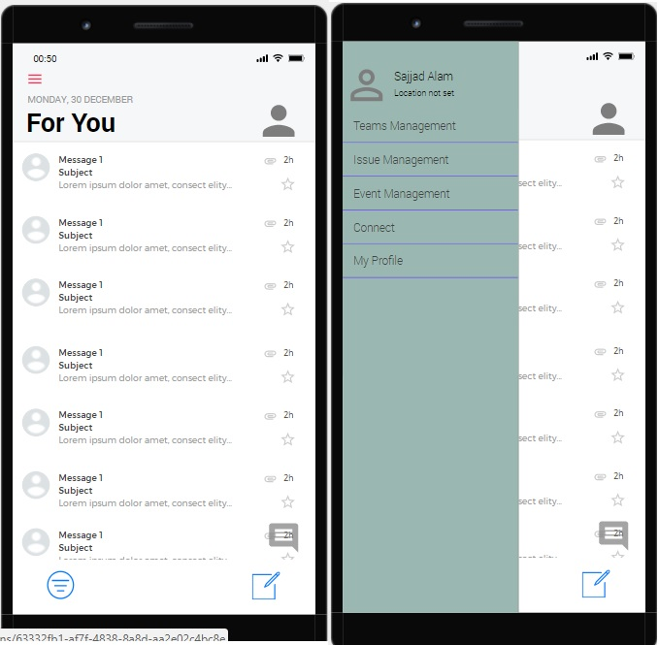

TEAM MANAGEMENT, ISSUE MANAGEMENT, PROFILE MANAGEMENT

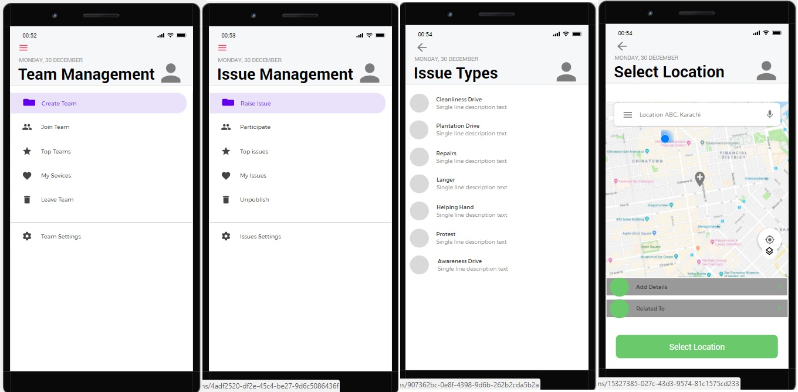

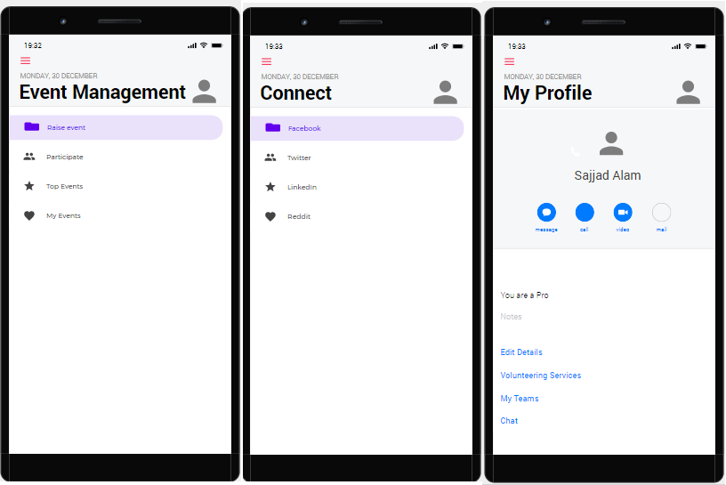

Fig. 16 Application Prototypes

# MILESTONE DETAILS

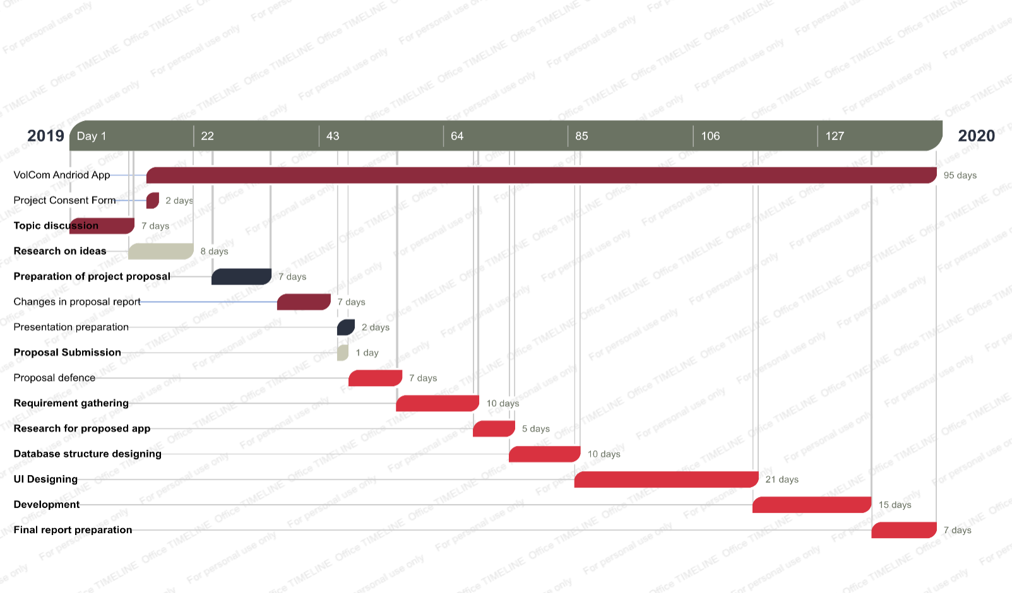

## SCHEDULE OF MILESTONE DESCRIPTION

|  |  |  |  |
| --- | --- | --- | --- |
| Name | START | | DUE |
| VolCom App: | | | |
| Consent form | 21/08/2019 | 22/08/2019 | |
| Topic discussion | 08/08/2019 | 18/08/2019 | |
| Research on ideas | 18/08/2019 | 28/08/2019 | |
| Preparation of project proposal | 01/09/2019 | 10/09/2019 | |
| Changes in proposal report | 12/09/2019 | 20/09/2019 | |
| Presentation preparation | 22/09/2019 | 24/09/2019 | |
| Proposal Submission | 22/09/2019 | 22/09/2019 | |
| Proposal defense | 24/09/2019 | 02/10/2019 | |
| Requirement gathering | 02/09/2019 | 15/10/2019 | |
| Research for proposed app | 15/11/2019 | 21/11/2019 | |
| Database structure designing | 21/10/2019 | 1/11/2019 | |
| UI Designing | 1/11/2019 | 1/12/2019 | |
| Development | 1/12/2019 | 20/12/2019 | |
| Final report preparation | 21/12/2019 | 31/12/2019 | |

# APPENDICES

* + Constraint: limitations, restrictions
  + Convention: meeting, conference, gets together
  + Database: record, file
  + Deformations: change in system forcefully
  + Degradation: congestion control
  + Dependencies: Needs
  + Modular: In component
  + Objectives: goals
  + Perspective: point of view
  + Platform: policy, proposal
  + Self-contained: self-sufficient, independent
  + Specification: requirement, plan, condition
  + Standardized: consistent, uniform
  + Transactions: dealings, contacts, business
  + SM: Social Media

# REFERENCES

[1] “Volunteerism — letting our youth fix Pakistan,” *dawn*. [Online]. Available: <https://www.dawn.com/news/1161476>.

[2] The spirit of volunteerism. [Online]. Available: <https://tribune.com.pk/story/461074/the-spirit-of-volunteerism/>.

[3] <https://www.volunteermatch.org/>.

[4] Volunteering and its Surprising Benefits [Online]. Available: <https://www.helpguide.org/articles/healthy-living/volunteering-and-its-surprising-benefits.htm>.

[5] The Self-Directed Volunteer – with Susan j. Ellis. [Online]. Available: <https://www.energizeinc.com/hot-topics/2010/may>.

[6] <https://www.givegab.com/>

[7]Understanding volunteer motivation for participation in a community‐based cooperative

<https://onlinelibrary.wiley.com/doi/abs/10.1002/nvsm.199>